Robust clipped correlation: EURUSD and GBPUSD
Method 04 / daily log returns clipped at ±0.01, ±0.02, ±0.03 / Alpari D1 full available history

Study setup
Logical pair: EURUSD , GBPUSD
Broker symbols: EURUSD_i , GBPUSD_i
Snapshot: 2026-11-03_majors_alpari_D1
Timeframe: D1
Matched return window: 1999-01-05 to 2026-11-02 (UTC bar dates)
Matched return count n: 7202
Dropped unfinished last bar dated 2026-11-03 UTC after a tick-volume check against the prior complete day.
Clip bounds c in log-return units: 0.01, 0.02, 0.03 (about ±1%, ±2%, ±3% on the log scale). Headline c = 0.02.
Clipping caps a day's magnitude at ±c and keeps the row; it does not drop the day, so n is the same at every c.
Complete matched rows (Excel): EURUSD-GBPUSD_Clipped_D1.xlsx
Complete matched rows (HTML table): EURUSD-GBPUSD_Clipped_D1_data.html

Method carried forward
Each matched daily log return of close, ln(close_t / close_t-1), is clipped in the broker quote direction before Pearson correlation: x_tilde = min(c, max(-c, x)) and y_tilde = min(c, max(-c, y)), then rho_clip = Pearson(x_tilde, y_tilde) on the same rows as raw Pearson r. Quotes are not inverted. A day beyond ±c stays in the sample at the cap; n does not change. rho_clip is symmetric under swap of the two symbols. rho_clip = 0 means no straight-line link among the clipped values in this sample; it does not mean no link of any kind. The score is not a cause, not a lead, and not a trading signal. Daily rows are not independent draws, so the two-sided p-value and Fisher interval are reported and treated as secondary to rho_clip. Cap-hit counts (|log return| > c) flag how much of each leg was capped.

Raw Pearson on the same rows
Pearson r: 0.641738
Two-sided p-value: 0
Approximate 95% Fisher interval: [0.627949, 0.655124]
This is the unclipped comparison required by the method. The headline score is rho_clip at c = 0.02 below.

Clipped results
n = 7202 at every c. Headline row is c = 0.02. Cap-hit count is the number of days with |log return| > c before clipping.
c | rho_clip | p | ci_low | ci_high | rho_minus_r | EURUSD_cap_hits | GBPUSD_cap_hits | EURUSD_cap_share | GBPUSD_cap_share
0.01 | 0.649871 | 0 | 0.6363264 | 0.66301589 | 0.0081334184 | 622 | 513 | 0.086365 | 0.07123
0.02 | 0.648213 | 0 | 0.634618 | 0.66140692 | 0.0064749679 | 41 | 39 | 0.005693 | 0.005415
0.03 | 0.646146 | 0 | 0.63248901 | 0.6594015 | 0.0044080419 | 4 | 11 | 0.000555 | 0.001527

Conclusion
Over 7202 matched daily log-return rows for EURUSD and GBPUSD (broker quote directions unchanged), headline robust clipped correlation at c=0.02 is 0.6482 (positive, moderate straight-line association among clipped values in this sample). Approximate 95% Fisher interval on the clipped series: [0.6346, 0.6614]. Same-sample raw Pearson r is 0.6417 (rho_clip minus r = 0.0065). Sensitivity across the fixed grid: c=0.01 same sign; c=0.02 same sign; c=0.03 same sign. Two-sided p under the usual independent bivariate-normal model is 0; that model does not match linked daily FX returns, so treat p as secondary. This does not establish cause, lead-lag, or a lasting trading rule.

What to look at in this file next time
1) rho_clip at c = 0.02 versus raw Pearson r. 2) Whether c = 0.01 and c = 0.03 keep the same sign as 0.02. 3) Cap-hit counts before treating a large gap as settled. 4) The ±0.02 lines on the returns chart and the clip box on the scatter.

Charts
Daily closes

Daily log returns with +/- 0.02 clip lines
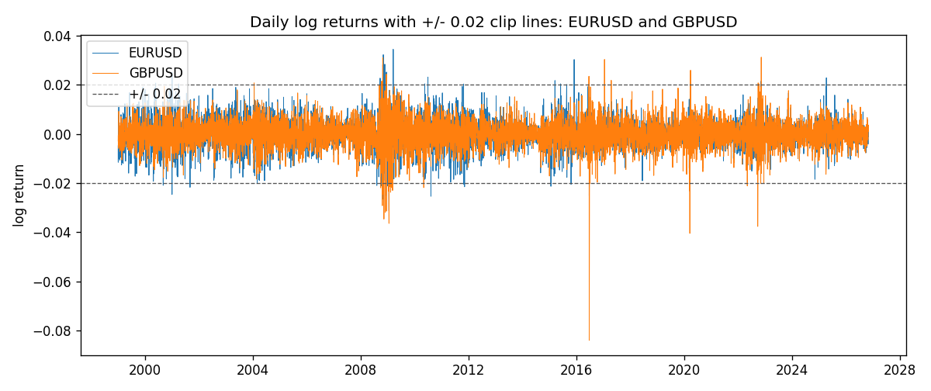
Log-return scatter with +/- 0.02 clip box
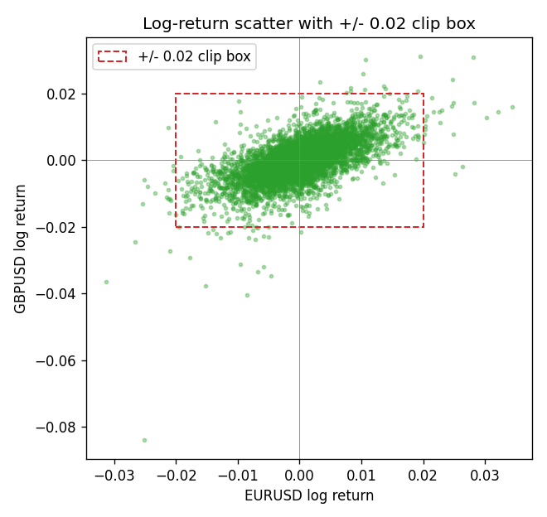

Data report
Every matched row that entered the clipped and raw correlations is stored in the sibling Excel workbook named EURUSD-GBPUSD_Clipped_D1.xlsx. That file is the complete data archive for redrawing charts. Embedding all rows as a Word table is impractical at this length; the Word file holds the column list, column summaries, and the first and last 15 matched rows.
Columns: time, EURUSD_open, GBPUSD_open, EURUSD_high, GBPUSD_high, EURUSD_low, GBPUSD_low, EURUSD_close, GBPUSD_close, EURUSD_tick_volume, GBPUSD_tick_volume, EURUSD_spread, GBPUSD_spread, EURUSD_real_volume, GBPUSD_real_volume, EURUSD_log_return, GBPUSD_log_return, EURUSD_log_return_clip_0p01, GBPUSD_log_return_clip_0p01, EURUSD_log_return_clip_0p02, GBPUSD_log_return_clip_0p02, EURUSD_log_return_clip_0p03, GBPUSD_log_return_clip_0p03
Column summaries (matched calculation rows)
column | count | mean | std | min | 25% | 50% | 75% | max
EURUSD_open | 7202 | 1.1812936 | 0.15087968 | 0.8272 | 1.086065 | 1.166145 | 1.293925 | 1.5995
GBPUSD_open | 7202 | 1.5160822 | 0.2182507 | 1.06854 | 1.325005 | 1.51141 | 1.63166 | 2.1066
EURUSD_high | 7202 | 1.1864255 | 0.15147858 | 0.8326 | 1.0901775 | 1.17127 | 1.2992275 | 1.6038
GBPUSD_high | 7202 | 1.5223773 | 0.21881719 | 1.08366 | 1.329795 | 1.51815 | 1.63839 | 2.1161
EURUSD_low | 7202 | 1.1762813 | 0.15020267 | 0.8227 | 1.0819975 | 1.162535 | 1.288315 | 1.5865
GBPUSD_low | 7202 | 1.5097565 | 0.21747799 | 1.03518 | 1.3195075 | 1.503295 | 1.6243825 | 2.0983
EURUSD_close | 7202 | 1.1813323 | 0.15085599 | 0.8267 | 1.0860025 | 1.166105 | 1.2939475 | 1.5997
GBPUSD_close | 7202 | 1.5161468 | 0.21820921 | 1.06879 | 1.325125 | 1.511325 | 1.632095 | 2.1065
EURUSD_tick_volume | 7202 | 102990.53 | 173401.83 | 218 | 9388.25 | 52708 | 99433.75 | 1471626
GBPUSD_tick_volume | 7202 | 94813.509 | 153540.37 | 62 | 9988.5 | 52886.5 | 91789.25 | 1273370
EURUSD_spread | 7202 | 19.400444 | 16.577153 | 0 | 8 | 12 | 30 | 50
GBPUSD_spread | 7202 | 26.974313 | 19.194125 | 0 | 11 | 20 | 50 | 50
EURUSD_real_volume | 7202 | 4.0233049e+10 | 1.6674277e+11 | 0 | 0 | 0 | 0 | 3.6149665e+12
GBPUSD_real_volume | 7202 | 3.5555961e+09 | 8.4432361e+10 | 0 | 0 | 0 | 0 | 2.4038164e+12
EURUSD_log_return | 7202 | -7.71e-06 | 0.00580133 | -0.03123819 | -0.00324586 | 0 | 0.00325471 | 0.03433183
GBPUSD_log_return | 7202 | -2.587e-05 | 0.00564523 | -0.08388241 | -0.00313091 | 3.124e-05 | 0.00317757 | 0.03112653
EURUSD_log_return_clip_0p01 | 7202 | -1.02e-05 | 0.00501073 | -0.01 | -0.00324586 | 0 | 0.00325471 | 0.01
GBPUSD_log_return_clip_0p01 | 7202 | 1.299e-05 | 0.00484379 | -0.01 | -0.00313091 | 3.124e-05 | 0.00317757 | 0.01
EURUSD_log_return_clip_0p02 | 7202 | -1.375e-05 | 0.00571584 | -0.02 | -0.00324586 | 0 | 0.00325471 | 0.02
GBPUSD_log_return_clip_0p02 | 7202 | -3.1e-06 | 0.00542891 | -0.02 | -0.00313091 | 3.124e-05 | 0.00317757 | 0.02
EURUSD_log_return_clip_0p03 | 7202 | -8.46e-06 | 0.00579536 | -0.03 | -0.00324586 | 0 | 0.00325471 | 0.03
GBPUSD_log_return_clip_0p03 | 7202 | -1.374e-05 | 0.00553779 | -0.03 | -0.00313091 | 3.124e-05 | 0.00317757 | 0.03
First 15 matched rows (selected columns)
time | EURUSD_close | GBPUSD_close | EURUSD_log_return | GBPUSD_log_return | EURUSD_log_return_clip_0p02 | GBPUSD_log_return_clip_0p02
1999-01-05 | 1.1758 | 1.6547 | -0.0048360507 | -0.0028966287 | -0.0048360507 | -0.0028966287
1999-01-06 | 1.1623 | 1.6537 | -0.011547966 | -0.00060452184 | -0.011547966 | -0.00060452184
1999-01-07 | 1.1712 | 1.6502 | 0.0076280636 | -0.002118709 | 0.0076280636 | -0.002118709
1999-01-08 | 1.1585 | 1.6405 | -0.010902799 | -0.0058954193 | -0.010902799 | -0.0058954193
1999-01-11 | 1.1503 | 1.6312 | -0.007103287 | -0.0056851331 | -0.007103287 | -0.0056851331
1999-01-12 | 1.1555 | 1.6349 | 0.0045103728 | 0.0022657001 | 0.0045103728 | 0.0022657001
1999-01-13 | 1.1681 | 1.6499 | 0.010845346 | 0.0091330396 | 0.010845346 | 0.0091330396
1999-01-14 | 1.1681 | 1.6531 | 0 | 0.0019376331 | 0 | 0.0019376331
1999-01-15 | 1.1563 | 1.6502 | -0.010153245 | -0.0017558204 | -0.010153245 | -0.0017558204
1999-01-18 | 1.1605 | 1.6522 | 0.0036256946 | 0.0012112405 | 0.0036256946 | 0.0012112405
1999-01-19 | 1.1603 | 1.6553 | -0.00017235436 | 0.0018745281 | -0.00017235436 | 0.0018745281
1999-01-20 | 1.1566 | 1.6472 | -0.0031939256 | -0.0049053846 | -0.0031939256 | -0.0049053846
1999-01-21 | 1.1601 | 1.6524 | 0.0030215416 | 0.0031518998 | 0.0030215416 | 0.0031518998
1999-01-22 | 1.1587 | 1.6565 | -0.0012075213 | 0.0024781662 | -0.0012075213 | 0.0024781662
1999-01-25 | 1.1552 | 1.6585 | -0.0030251979 | 0.0012066366 | -0.0030251979 | 0.0012066366
Last 15 matched rows (selected columns)
time | EURUSD_close | GBPUSD_close | EURUSD_log_return | GBPUSD_log_return | EURUSD_log_return_clip_0p02 | GBPUSD_log_return_clip_0p02
2026-10-13 | 1.11965 | 1.32534 | 0.0037402957 | 0.0036434319 | 0.0037402957 | 0.0036434319
2026-10-14 | 1.11545 | 1.31884 | -0.0037582255 | -0.0049164679 | -0.0037582255 | -0.0049164679
2026-10-15 | 1.12172 | 1.32757 | 0.0056053107 | 0.0065976411 | 0.0056053107 | 0.0065976411
2026-10-16 | 1.12371 | 1.33257 | 0.0017724895 | 0.0037592051 | 0.0017724895 | 0.0037592051
2026-10-19 | 1.12086 | 1.33024 | -0.0025394633 | -0.0017500314 | -0.0025394633 | -0.0017500314
2026-10-20 | 1.12354 | 1.3377 | 0.0023881672 | 0.0055923442 | 0.0023881672 | 0.0055923442
2026-10-21 | 1.12318 | 1.33937 | -0.00032046717 | 0.0012476328 | -0.00032046717 | 0.0012476328
2026-10-22 | 1.12139 | 1.33967 | -0.0015949606 | 0.00022396082 | -0.0015949606 | 0.00022396082
2026-10-23 | 1.11989 | 1.33684 | -0.001338521 | -0.0021146949 | -0.001338521 | -0.0021146949
2026-10-26 | 1.11735 | 1.33359 | -0.0022706559 | -0.0024340661 | -0.0022706559 | -0.0024340661
2026-10-27 | 1.11272 | 1.33044 | -0.004152342 | -0.0023648393 | -0.004152342 | -0.0023648393
2026-10-28 | 1.1152 | 1.33254 | 0.0022262927 | 0.0015771808 | 0.0022262927 | 0.0015771808
2026-10-29 | 1.11772 | 1.33733 | 0.0022571351 | 0.0035881935 | 0.0022571351 | 0.0035881935
2026-10-30 | 1.11644 | 1.33913 | -0.0011458446 | 0.0013450605 | -0.0011458446 | 0.0013450605
2026-11-02 | 1.11881 | 1.3406 | 0.002120569 | 0.0010971256 | 0.002120569 | 0.0010971256

